Managed Availability Troubleshooting Beginners Guide

1. Open Powershell as an Admin
2. This can be run from an Exchange server and it will list out all recover actions taken by MA for that server.
   1. $RecoveryActionResultsEvents = Get-WinEvent –ComputerName <Server>-LogName Microsoft-Exchange-ManagedAvailability/RecoveryActionResults
   2. $RecoveryActionResultsXML = ($RecoveryActionResultsEvents | Foreach-object -Process {[XML]$_.toXml()}).event.userData.eventXml | Select EndTime, ID, State, ResourceName, RequestorName,Result| Out-GridView
3. Output will be similar to below.  Take note of the RequestorName of the ID (what happened or is happening to the server)



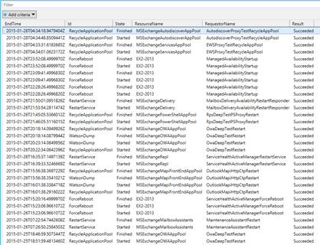

1. Now we find the Monitor that triggered the action. Run the below:
   1. $DefinedResponders = (Get-WinEvent –ComputerName <Server> -LogName Microsoft-Exchange-ActiveMonitoring/ResponderDefinition | % {[xml]$_.toXml()}).event.userData.eventXml
   2. $DefinedResponders | ? {$_.Name –eq "TheRequestorNameFromAbove"} | select TypeName,Name,TargetResource,AlertMask,WaitIntervalSeconds | Out-GridView

It Should look something like this take note of the AlertMask (monitor that triggered the responder)

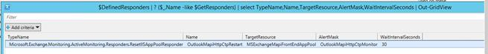

1. Now we can find out which probe(s) that feed data to that monitor.
   1. $DefinedMonitors = (Get-WinEvent –ComputerName <Server> -LogName Microsoft-Exchange-ActiveMonitoring/MonitorDefinition | % {[xml]$_.toXml()}).event.userData.eventXml
   2. ($DefinedMonitors | ? {$_.Name -eq ‘ServiceHealthMSExchangeReplEndpointMonitor’}).SampleMask

cid:image011.png@01D03B48.A3CC1750

1. You can now use that Probe as your investigation point.